**SYSC 4203**

**Heart-rate variability analysis**

**Joshua Hayles**

**101031998**

**Adam Rocco**

**101025114**

**Dec 6th2019**

**Introduction:**

Alcoholic beverages have been enjoyed by humanity for longer than recorded history. The time in which one drinks the most alcoholic beverages on average is when they are a student. It is well known that drinking too much alcohol leads to all sorts of ill effects such as headaches and vomiting. The majority of alcohol effect is on the brain. However, what effect does it have on other vital organs of the body? In the case of this study, the organ of interest is the heart. The particular parameter of the heart that is to be studied is that of heart rate variability (HRV). Through this experiment it will be determined if alcohol consumption has an effect of the HRV.

**Methods (Experimental):**

The experimental method for collecting data to determine alcohol's effect on an individual's HRV is as follows. The participants ECG data was collected before the participant consumed alcohol. This data collection occurred while the participant was seated in a resting position. The participant was then taken to Oliver's pub where they consumed 1 pint (16 oz) of beer over a 20 minute time span. The participant was then taken back to the lab where they rested for 5 mins. After this 5 min rest period their ECG data was again collected. The Exclusion Criteria for this experiment was as follows: participants under 19 years of age and participants whom don't already drink.

**Methods (Electronics Design):**

The ECG measurement circuit as seen below in figures 1 and 2 was comprised of the interconnection of 7 IC’s. These IC’s were connected in the following order: the instrumentation amplifier AD620 was connected to the Op97 precision amplifier. The Op97 was utilized in a driven right leg configuration with the AD620 instrumentation amplifier which helped remove the common mode signal from the output of the circuit. LA and RA leads where connected to the instrumentation amplifier for amplification. The Rg resistor for the AD620 was selected so that a small gain of approximately 6 was introduced to the signal. From the instrumentation amplifier the signal was fed into a LM741 amplifier that was configured to be a 2nd order sallen key LPF filter with a cutoff of 35Hz. This filter removed the majority of noise from the signal. The majority of noise in the signal is due to the 60 hz power line interference. The output of the LPF filter was then fed into another LM741 amplifier which was configured as a sallen key high pass filter with a cutoff frequency of 3.5Hz. This filter removed the wandering baseline from the signal, resulting in a flat signal centered about 0 V. After the HPF the signal was fed to another LM741 which was configured to be a gain stage providing an approximate gain of 560. From the output of the gain stage the signal was fed into a ISO124 which was used to isolate the individual connected to the board from the computer that the circuit terminated in via the auxiliary cable which was plugged into the auxiliary port of the PC. This entire circuit, with the exception of one side of the ISO124 power supply, was powered by the single supply circuit which can be seen in figure one below. This single supply circuit consisted of a 9v battery, an LM741 which was configured as a buffer and a voltage divider. For the entire circuit schematic refer to figures 1 and 2 below.

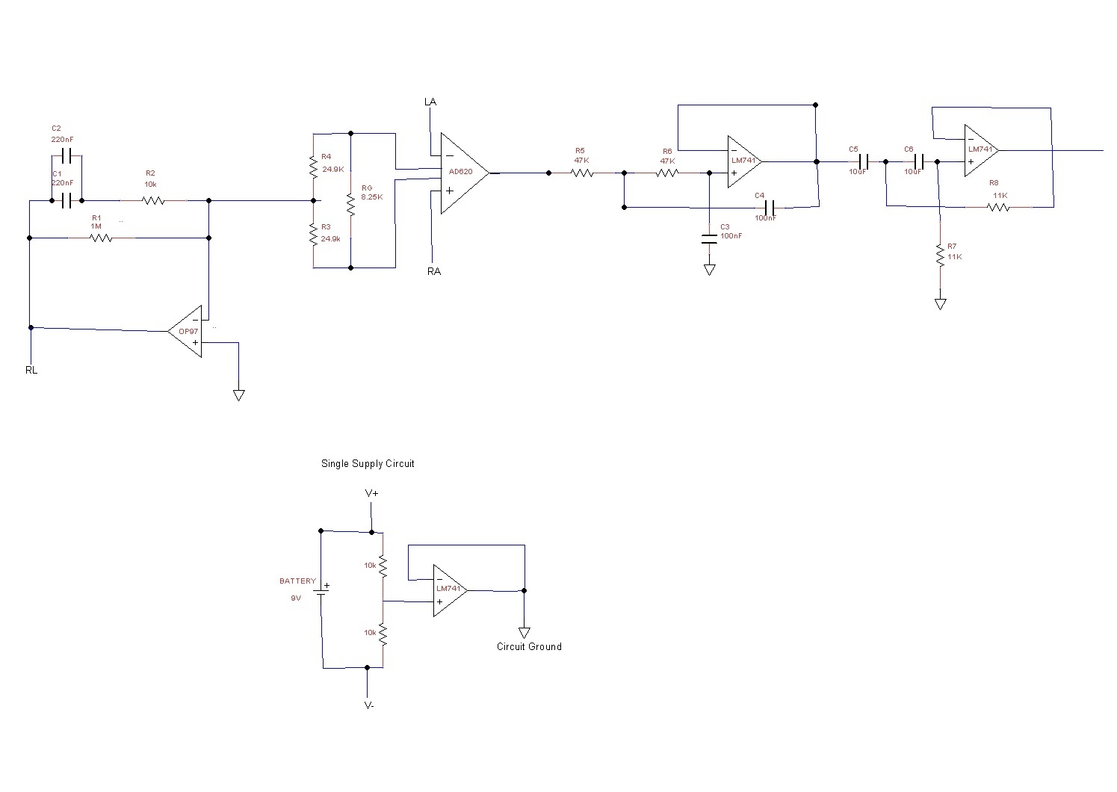Figure 1 . Stage One of Circuit

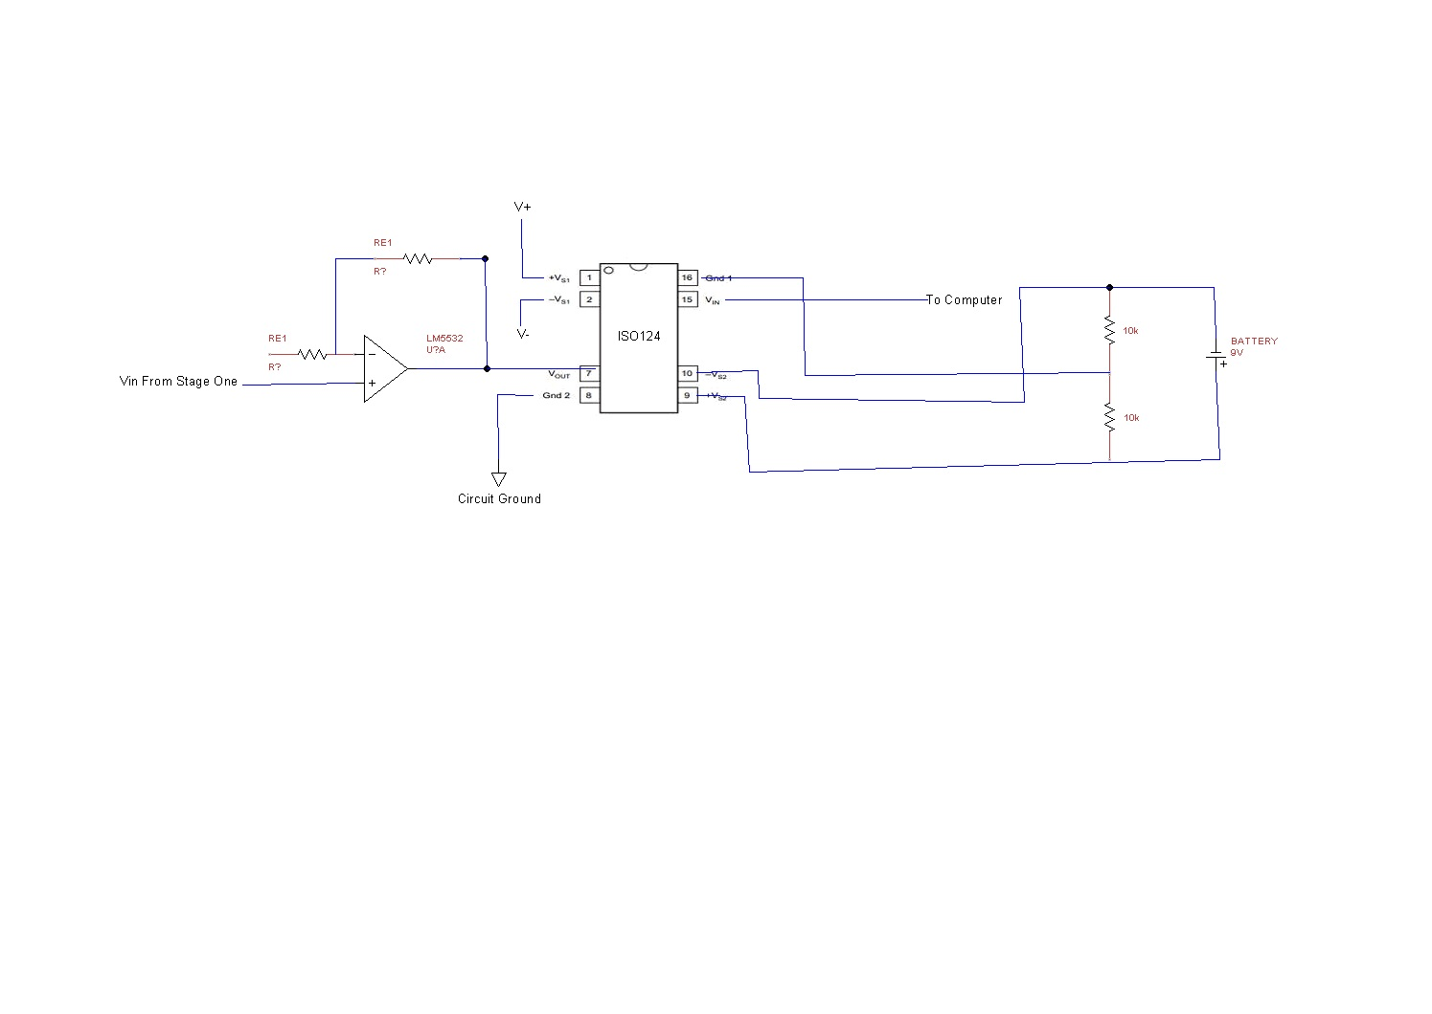

Figure 2: Stage 2 of Circuit

**Calculations:**

To measure the common mode gain, the entire circuit was connected. The input signal was supplied into the instrumentation amplifier (V+ to +, V-  to +), and the output was measured after the gain stage of the circuit. Using an 8mV sin wave @ 100 Hz a common mode gain of 2 was obtained as 14mV/7mV = 2. To measure the differential mode gain of the circuit the entire circuit was connected. The input signal was supplied at the instrumentation amplifier (V+ to +, V- to ground). The output was measured at the output of the gain stage. Using an 8mV sin wave @ 100 Hz, a differential gain of 533 was obtained as 4.1V/7.50mV = 533. The common mode rejection ratio (CMRR) is determined using the following formula

 Eq.1

Substituting the experimentally determined values of Ad and Ac into Equation, one yields a CMRR of approximately 46.50 dB. The Frequency response of the LPF was calculated by varying the frequency of the input and measuring the output then calculating the gain.

− Roll-off rate/Absolute cutoff

* High

35 Hz - Actual

33 Hz - Expected

370 Hz - Absolute

Roll off rate: 29 dB/decade

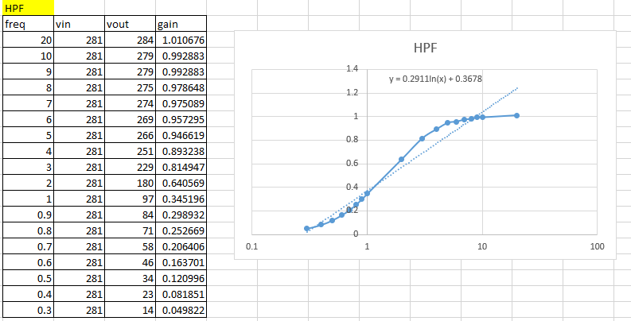

Figure 3: High pass filter roll off rate found from decreasing frequency

* Low

3.5 Hz - Actual

1.33 Hz - Expected

150 mHz - Absolute

Roll off rate: -0.29 dB/decade

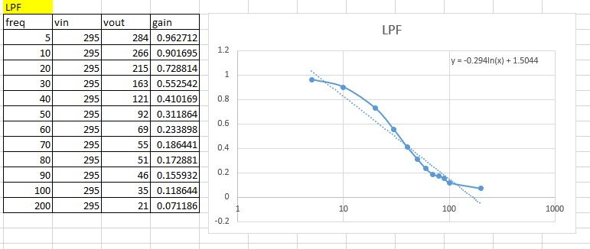

Figure 4: Low pass filter roll off rate found from increasing frequency

**Methods (HRV analysis):**

* **Description of the HRV analysis.**

HRV analysis is one of the most sought after values in the medical world today, especially because of the medical wearables boom. HRV is Heart Rate Variability, and it describes the ability to change heart rates during day to day activity. Having a high HRV is actually a good thing, it allows the body to tolerate changes in stress, including beginning or ending exercise, or anything that puts a physical or mental stress on the body. One way to calculate HRV is to measure the time difference in between R wave peaks in an ECG signal. Then using RMSSD one can calculate the average change between heart beats.

* **Show a sample of raw ECG data**

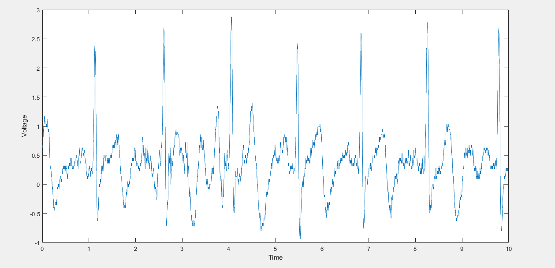

Figure 5: Raw ECG data from Our Built Circuit

* **Choose/Implement a method to detect QRS R-peaks**

The method chosen to detect the R-peaks is the Pan-Thompkins algorithm, this is the algorithm followed to create circuit therefore it will also be the algorithm to detect the R-R peak times.

* **Validate (visually) the success of your R-peak detection.**

The R-Peak detection was successful, by looking at figure6, it can be seen that the peaks were correctly identified, and represented by a star at the top of the square wave, the distance (time) between these points were then measured to compute the R-R interval time.



Figure 6: Location of R-Peaks (represented by a star)

* **Choose an HRV parameter and describe it**

An example of a key HRV parameter is detecting anomalous events. It is well known what a heart signal should look like on an ECG, they follow the QRS waveform, and this shape repeats itself with consistent timing (depending on your HR). It would be very difficult to detect faults through an entire ECG signal, so by looking for anomalies in the timing of the wave, certain things could be told about the patient. For example if between R waves there were multiple P waves (wavy signal) this could indicate a slow ventricular response or atrial fibrillation. So by analyzing specific parameters, doctors can accurately predict problems with the heart very efficiently, as opposed to analyzing pages and pages of data.

* **Describe and show the analysis software that you used/wrote**

The first block of code stated the values of FR and line width, which were both needed to calculate our time axis. I also loaded in our desired file to analyze using matlab's csvread function. Initially, I detrended the data but by plotting the signals that use the detrended data and the signals that used the raw data, it returned the same results. The next block was calling Professor Adler’s freq_filt function, I chose to filter frequencies less than 30 Hz. As well as Plotting the three ECG traces, one was the filtered detrended data, one was the raw filtered data and the other was the raw unfiltered data. All x axis’ were limited to 30.

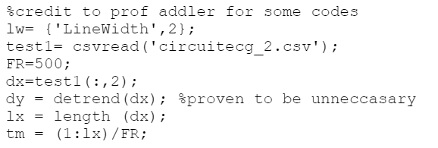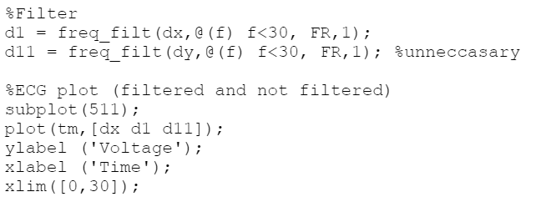

Figure 7: Block 1 Figure 8: Block 2

Block 3 of the code was done by professor Adler and it plotted the signals in the frequency domain. Block 4 was the implementation of the Pan-Tompkins algorithm by convoluting the filtered raw data, with a -1 1 column matrix storing it in d2, and then taking the absolute value of d2. By creating only positive values, we can then create an envelope over the peaks. This is one method I attempted, I also used Professor Addler’s freq_filt function and filtered frequencies above 10 Hz, creating a similar curve to the envelope.

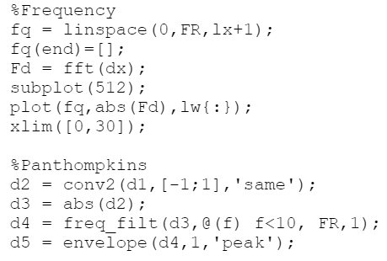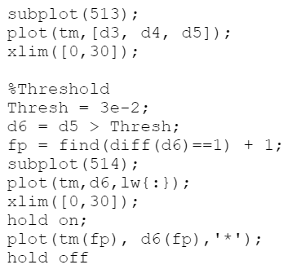

Figure 9: Block 3 and Block 4 Figure 10: Block 5

I then plotted the absolute value curve, the envelope, and the curve from the filter function in block 5. The two curves were very similar and followed the peaks well. By setting a threshold of 0.03V, I then assigned all the values of the envelope that were over the threshold to a new variable d6, and found where it crossed that threshold, and marked the point with a star. I also plotted d6, the stars were at the top left corner as seen in figure 6.

Lastly in block 6 I calculated the difference of these stars by using matlab’s diff function and plotted those against the line width to give a visual representation of heart rate variability.

The last two lines display all the R-R intervals in the command window and output the avgRR calculation.

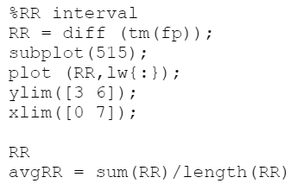

Figure 11: Block 6

* **A plot of sample HRV results**

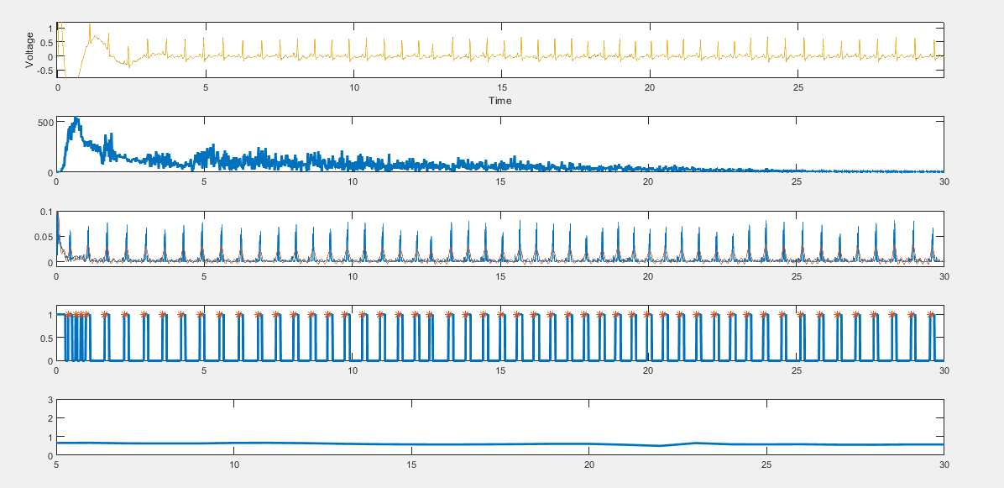

Figure 12: HRV results, (TOP to BOTTOM) Filtered ECG, Frequency Domain, Pan-Tompkins, R peak location (represented by stars), RR interval Times

* **The HRV parameter values for each subject in the before/after group**

Table 1: Subject 1-4 R-R interval times before and after 16oz of Molson Canadian

| **Subject** | **R-R AVG Before (ms)** | **R-R AVG After (ms)** |
| --- | --- | --- |
| **Om** | 557.8 | 626.5 |
| **Majd** | 671.3 | 713.7 |
| **Josh** | 699.1 | 802.3 |
| **Adam** | 536.6 | 528.6 |

In order to visually compare Heart Rate Variability, one can look at the final plot (as seen in figure 7), the more linear the plot, the more consistent the heart rate was, meaning the lower the HRV was. If the bottom plot appears to be changing values consistently, then the variability increased. Below it can be seen that there is no consistent trend on the variability of heart rate between no alcohol versus one drink, so although heart rate tended to increase with alcohol it appears that heart rate variability does not consistently change person to person with alcohol.



Figure 13: Om Sober

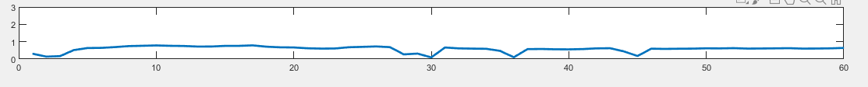

Figure 14: Om (one drink)

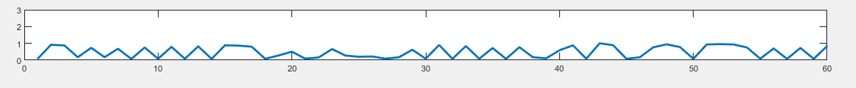

Figure 15: Majd Sober

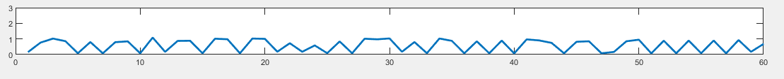

Figure 16: Majd (one drink)

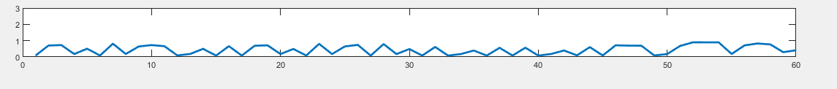

Figure 17: Josh Sober



Figure 18: Josh (one drink)

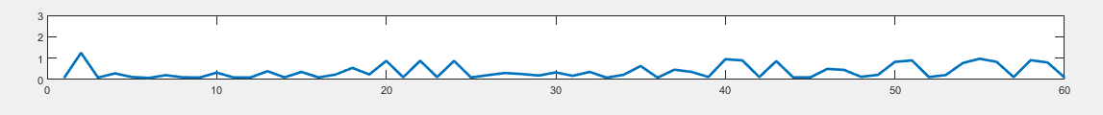

Figure 19: Adam Sober

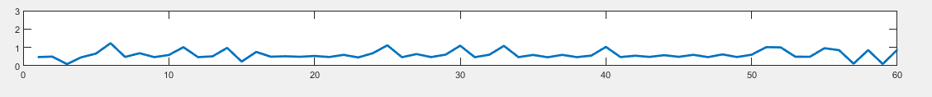

Figure 20: Adam (one drink)

**Discussion:**

* **How did your circuit perform? Did it meet your expectations?**

The Circuit performed well, it provided an ECG waveform which was clean and allowed for easy distinguishment of each portion of the waveform. The R waves were nicely emphasized which allowed for easy analytical calculation of HRV.

* **What did HRV analysis show? Were there any interesting physiological differences?**

The HRV analysis showed that there was a change in HRV with alcohol as a stressor. 3 out of 4 subjects actually increased their average R-R interval times, which means that the heart rate increased after having an alcoholic beverage. This is odd because alcohol is classified as a depressant, meaning your body typically slows down (breathing, speech), resulting in a lower HR, which is the exact opposite effect of our results. Om and Majd’s *variability* increased while Josh and Adam’s decreased. Perhaps this is connected to consumption habits, Josh and I tend to consume alcohol more regularly than Om and Majd, so maybe by building a tolerance to alcohol, our heart rate is affected less.

* **What is the answer to the scientific question you asked?**

The scientific question that was asked was “does alcohol affect heart rate variability?”. By analyzing the results it can be said that alcohol does not have a consistent effect on the heart rate variability of a person, but did tend to increase the patient's heart rate (¾ cases).

* **In light of these experiments, is your initial product idea a good one?**

Since there was no substantial scientific evidence obtained which proved that alcohol had an effect on the Heart rate variability it can be stated that the initial product idea is not a good one. This is the case as the product would fail to provide any meaningful information to the individual using it.